Data Team Summary
Anna Luther

- School Vision:
- Paste your school’s vision into this section.
“Creating a Culture of Greatness”
2. Enter your Wordle URL into this section (see Syllabus for details).

- Describe how your school’s data team can use data to measure meaningful progress toward realization of your school’s vision.

Our school can create a culture of greatness by ensuring that students are being taught in a way that suites their individual learning needs. We can use data as formative assessments as we are instructing to find strengths and weaknesses in the curriculum and address them with individual students as we continue to differentiate and re-teach/enrich the curriculum.
Creating a culture of greatness is not something that happens once, but a continual process that we must keep going throughout the course of the school year. In order to maintain a culture of greatness, our school’s faculty and staff must identify, recognize, and embrace our school cultural and intellectual diversities. Walk alongside families by maintaining constant communication and keeping clear expectation, as we educate their children. Most importantly, we must give students responsibility and ownership of their learning by having them track their data. In a culture of greatness, it is our responsibility to make sure each student has a stake in their learning, not just the teachers.
Finally, I believe in a culture of greatness there should be clear, attainable expectations and goals for students. When students know they have the support and tools they need to succeed, they are much more likely to invest in themselves. We have achieved a culture of greatness when the community, students, and parents know the goal and share the passion for learning. These goals can only be achieved by providing them with the data that supports their child’s goals

4. School demographics. (Courtesy of Cobb County School District)

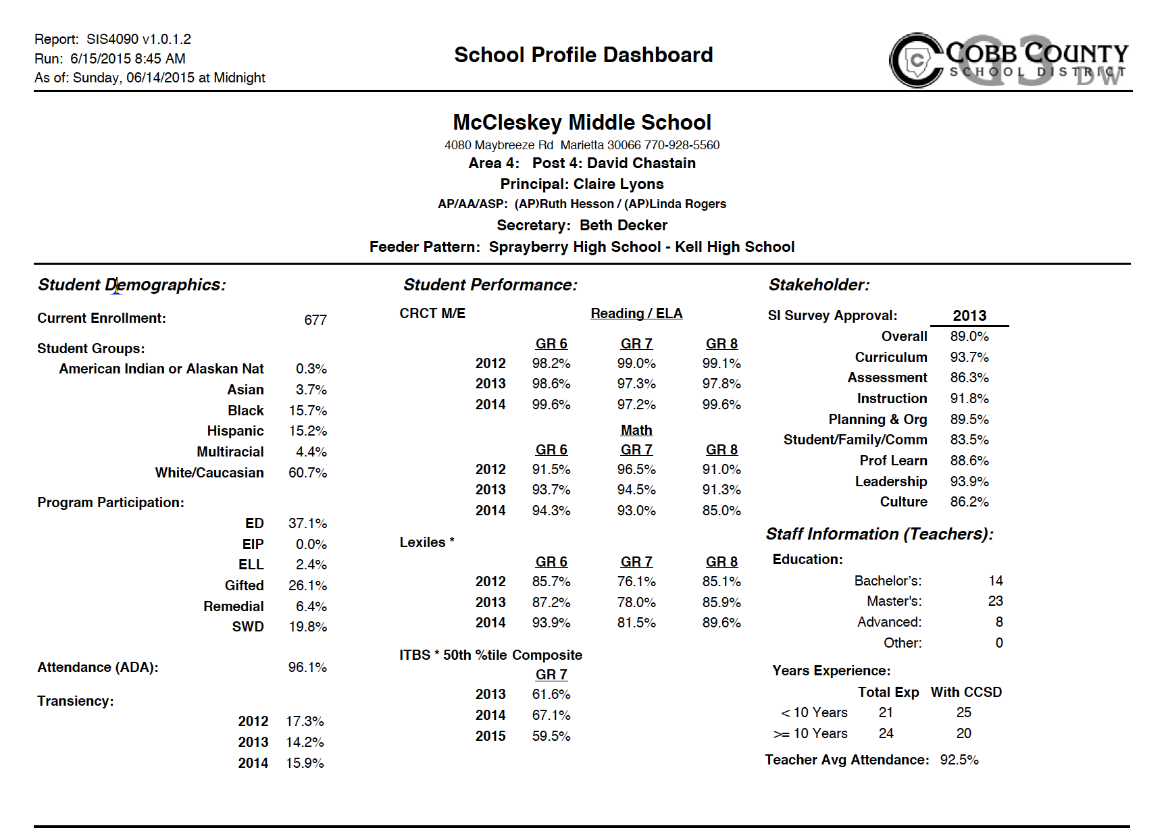

- Purpose & Roles of the Data Team:
At our school, data teams are done in grade level content areas. They have three teachers each: two content area teachers and one special education teacher. Each data team has the liberty to create their purpose and roles for the team. Here are the purpose and roles put in place by my content area team:
Purpose of the Data Team:

The seventh grade social studies data team exists to help students reach their maximum potential by working collaboratively to create common assessments, differentiating based of the results of data, and revising content and instruction to make future improvements to the curriculum.

Roles of the Data Team:

- Create common assessments
- Address individual students’ needs
- Differentiate based off of multiple intelligences, ability, and learning styles
- Revise content and instruction for future students

- Data Team Formation, Rationale & School Structures:
There are three data teams each member of the staff is a member of. These three teams allow for vertical and horizontal planning.
- Grade Level Team:
This is a meeting among each team to track students who are struggling in multiple content areas. The team addresses the conduct, grades, and motivation of the students. This team meets twice a month with the school counselors to discuss the needs of students and devise an individualized plan for each student to meet the standards for each class. When these interventions are set and the student is not making progress, the team will place the student on RTI if necessary.
- Content Area Team:
Content area data teams meet monthly during a portion of the content area meetings. The grade level team addresses concepts that are not translating from grade-to-grade. The team then comes up with appropriate lessons to implement to prevent this from becoming a trend.
- Grade Level Content Area Team:
This is the most intimate data team. This team plans together, creates assessments together, and revises content. They meet formally on a weekly basis, but they usually gather informally several times a week. These teachers also differentiate by using flexible grouping with the students. For example, after an assessment, the teachers will look at the result and divide the students into three groups: exceeds, meets, and does not meet. The exceeds will work with a teacher or do an independent extension, the meets works on an activity to refine their skills, and the does not meet does a lesson that focuses on reviewing and re-teaching concepts.

When the content area teams and grade level teams meet, there is always an administrator present to help the team make the best possible decisions. During grade level content area meetings, the grade level administrator will pop in approximately once a month, or more if they are struggling in a certain situation. If the team makes a decision without an administrator, they email the administrator before implementation to secure approval.

- Decision-Making Authority:
Data teams are given full permission to delegate and make decisions independently. Once the teams make their decisions, they notify administration for approval. This promotes clear expectations throughout the building.
Outreach Plan – Refer to Table 2.1, p. 31, Data Coach’s Guide

Audience | How will you engage them? | Their role in sustaining collaborative inquiry
District Administrators | We will share data with district administration using the Microsoft 365 application funded by the district. If necessary, we can meet in person, but minimally we will keep them in the loop by sharing our documents and adding comments back and forth as required. This will provide specific examples of what is happening in our classrooms, and show them examples of the support we need. | - Communicate vision clearly and often  - Help teachers revise content as necessary  - Requirement of curriculum, standards, and assessments  - Require participation from local administration  - Create a safe environments for data usage  - Provide teachers to feedback in real time  - Support the use and creation of common benchmark assessments
School Administrators | Our administration is a vital part to our data teams. We try to have administration included at a minimum of once a month in our data team discussions. Files will be shared with administration via Microsoft 365 if they are not available to be at the initial meeting. Before the data team moves forward with any process, the data team will present their ideas to administration and | - Communicate and discuss clear goals/expectations on a monthly basis  - Support, coach, and encourage teachers  - Create a safe environment for data use  - Model to practice of using data  - Regularly update faculty on county-wide data changes  - Help the team access materials  - Establish a time in the school schedule for data teams to meet  - Provide teachers up-to-date access to relevant data  - Empower teachers to make decisions based off data
School Faculty | The seventh grade social studies team will be piloting this model. As they navigate each step of the UDP process, they will present at the monthly faculty meeting. The team will slowly provide training to their grade level by January and the whole school by SY 16-17. | - Participate when information about the data teams is being conveyed  - Use the results of data to improve instruction  - Stay current with data team’s work  - Take responsibility for student learning  - Develop appropriate assessments that align with standards
Department Chairs | Check in with content area team members to se if they need support or more information, address concerns, coach teachers who are struggling. | - Support data team  - Participate in the data team  - Provide guidance and resources for the data teams  - Model using data in regular instructional practices  - Provide teachers with access to the data  - Advocate for collaborative inquiry among faculty  - Mentor new teachers on how to use data effectively
Instructional Leaders/Specialists | The instructional leaders will be the part of the staff that takes over the data teams. For now, they will sit in on the beginning discussions, offer suggestions, and be a part of planning instruction. | - Meet with data teams  - Pilot data team discussion/dialogue  - Help plan lessons/write assessments  - Mentor new teachers and new data teams as they enter the process  - Ensure all students are learning
Potential Data Team Members | Potential new candidates need to begin sitting in on data team meetings. One person on the data team should be their data mentor. This would preferably be someone who is on their grade level team that can assist them with this during planning. After the meetings, the mentor and the potential member need to have an informal debriefing about how to data team worked. This will be a time to ask questions and clarify what hap | - Support the data team  - Ask questions when something is not clear  - Understand how to implement UDP process  - Keep the vision alive  - Influence school culture
School Board Members | Along with administration, the school will make a video showing the board how we have implemented the process and what the results have been. Members of our data team will attend the meeting to facilitate questions. | - Support the data teams  - Ensure schools have access to useful resources  - Provide a budget that allows staff members to guide and support the data teams
School Improvement Team | Attend a school improvement meeting and spread the word about UDP. Discuss how the process supports students, teachers, and parents. | - Coordinate with the data team  - Model the practice of UDP to influence school improvement decisions
Parents | Introduce parents to UDP, including data, review this several times with them and take questions. An appropriate time to do this would be during open house, conference week, Edmodo, or the school newsletter. | - Keep them up to date on the team’s work and their child’s progress  - Participate in data team events catered for parents  - Respond to requests for data, such as surveys  - Contact the teacher with concerns
Data or Assessment Coordinators | Keep the staff updated on your plans and vision for everyone, work together, identify how each member of the school is an important piece to the data plan. | - Provide teachers access to view the data  - Stay in frequent communication  - Address concerns/questions promptly
Students | In the past, I have had a look at us grow garden in the classroom. Although it appears elementary, I offer jolly ranchers to  - The class that grows the most from the pre-assessment  - The class that maintains the highest average throughout the assessments  This has worked wonders in the middle school classroom. Students love competing with the other classes, and it keeps individual grades confidential. When they see the other class has a higher average than they do, they almost always have more motivation to study for the summative assessment. | - Ask questions about standards and assessments  - Provide informal feedback to the teacher about the assessments  - Give suggestions on how to improve the class for the next years.  - Give suggestions on strategies that helped them learn

